Class 3 – Global Energy Transition

Instructor: Nate Tucker

Date: 06-Feb-2021

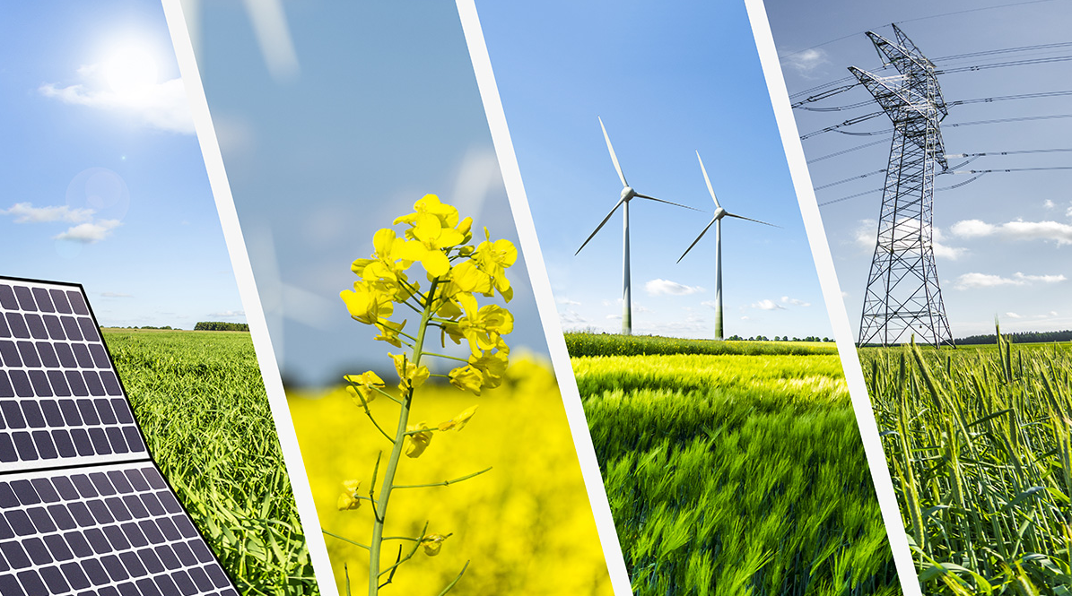

# Course Overview:

* 5 Saturday Meetings - Discussion oriented
  + Intro to Energy
  + Conventional Energy Sources (coal, natural gas, petroleum)
  + Renewable Energy Sources (solar, wind, geothermal, hydro)
  + Upcoming Technologies, Future Goals, Industry Shifts
  + Sustainability in our lives

# Feedback from Class 2

* What we learned
  + Limited supply of coal and oil in the world
  + Coal and oil are transported across the world for use
  + Oil can have some negative effects on the environment if not handled correctly
  + Coal and oil have been used as energy resources for a long time
  + Coal – mainly used for generating electricity (steam plant)
  + Oil – mainly used for transportation (i.e., refined into gasoline, diesel, etc.)
* Goals for today
  + Quicker (again)

# Investigation – Solar

1. Energy source name.
   1. Solar
2. Is it renewable or non-renewable?
3. If non-renewable, how many years of world/U.S. reserves are left?
4. Is it used for electricity generation, heating, and/or transportation fuel?
5. What percent of California’s electricity or heating does the source supply? What percent of the U.S.’s transportation fuel does the source supply?
6. How is the source converted into usable energy?
7. Can the energy source produce energy upon demand (instantly)?
8. Is the energy from the source commonly used where it is generated?
9. Use resource maps or other data to comment on the abundance of the source in California and in your region of California.
10. How does the cost of using the energy source compare to alternatives?
11. What are the environmental costs and benefits of the energy source, including impacts on wildlife habitat, ecosystems, and the atmosphere?
12. Do you believe the source is overutilized, underutilized, or utilized at the right level in California? Why?

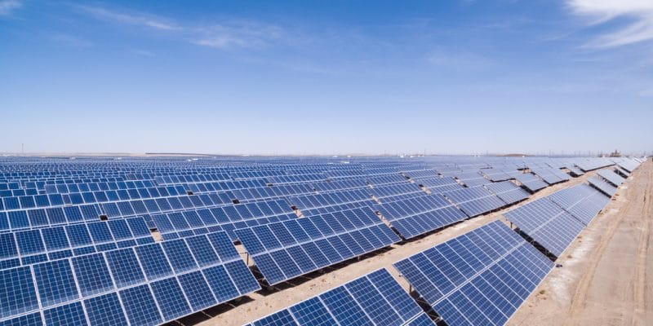

Solar Plant in Algeria

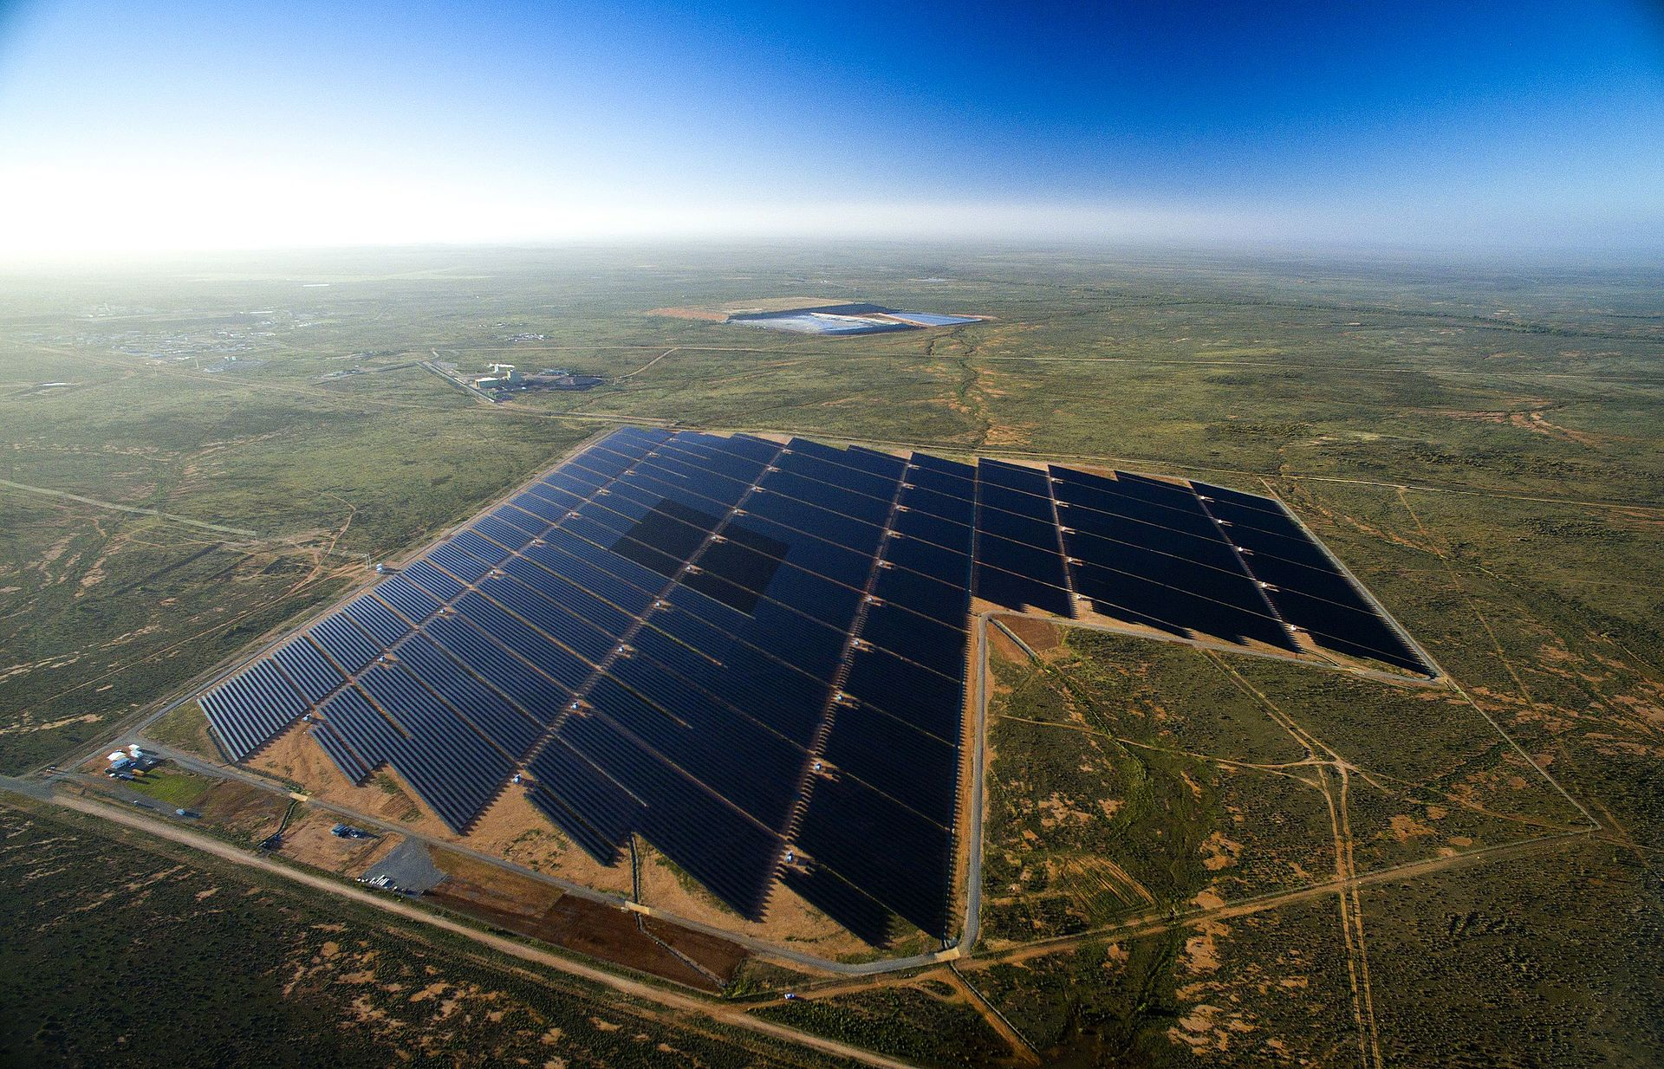

Solar Plant in Australia

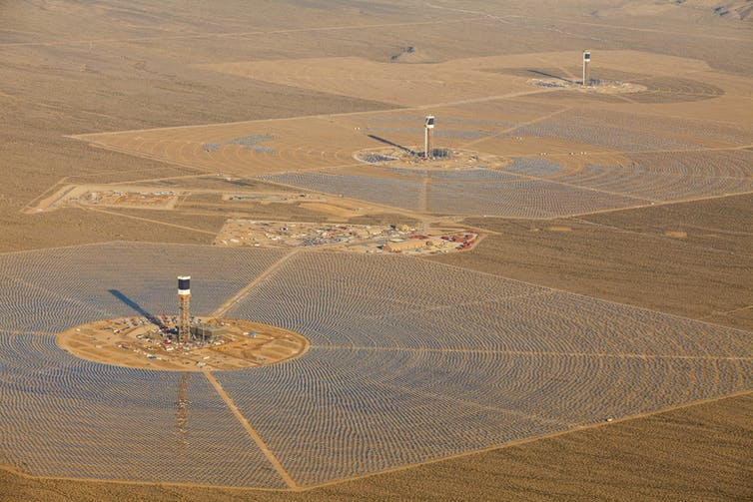

Ivanpah solar plant in California

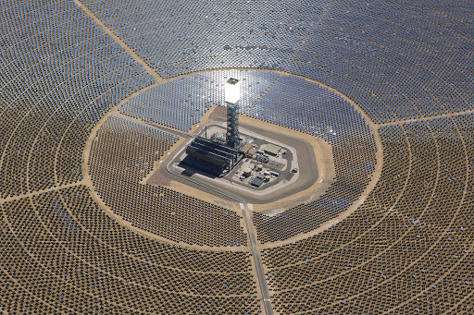

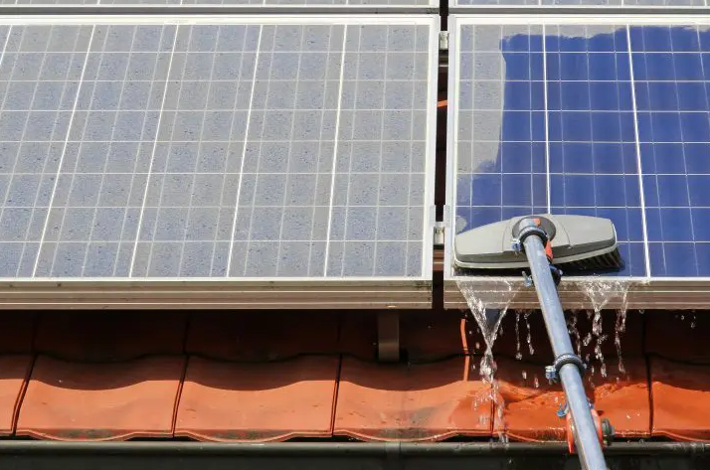

Solar panels need to be cleaned regularly

# Investigation – Wind

1. Energy source name.
   1. Wind
2. Is it renewable or non-renewable?
3. If non-renewable, how many years of world/U.S. reserves are left?
4. Is it used for electricity generation, heating, and/or transportation fuel?
5. What percent of California’s electricity or heating does the source supply? What percent of the U.S.’s transportation fuel does the source supply?
6. How is the source converted into usable energy?
7. Can the energy source produce energy upon demand (instantly)?
8. Is the energy from the source commonly used where it is generated?
9. Use resource maps or other data to comment on the abundance of the source in California and in your region of California.
10. How does the cost of using the energy source compare to alternatives?
11. What are the environmental costs and benefits of the energy source, including impacts on wildlife habitat, ecosystems, and the atmosphere?
12. Do you believe the source is overutilized, underutilized, or utilized at the right level in California? Why?

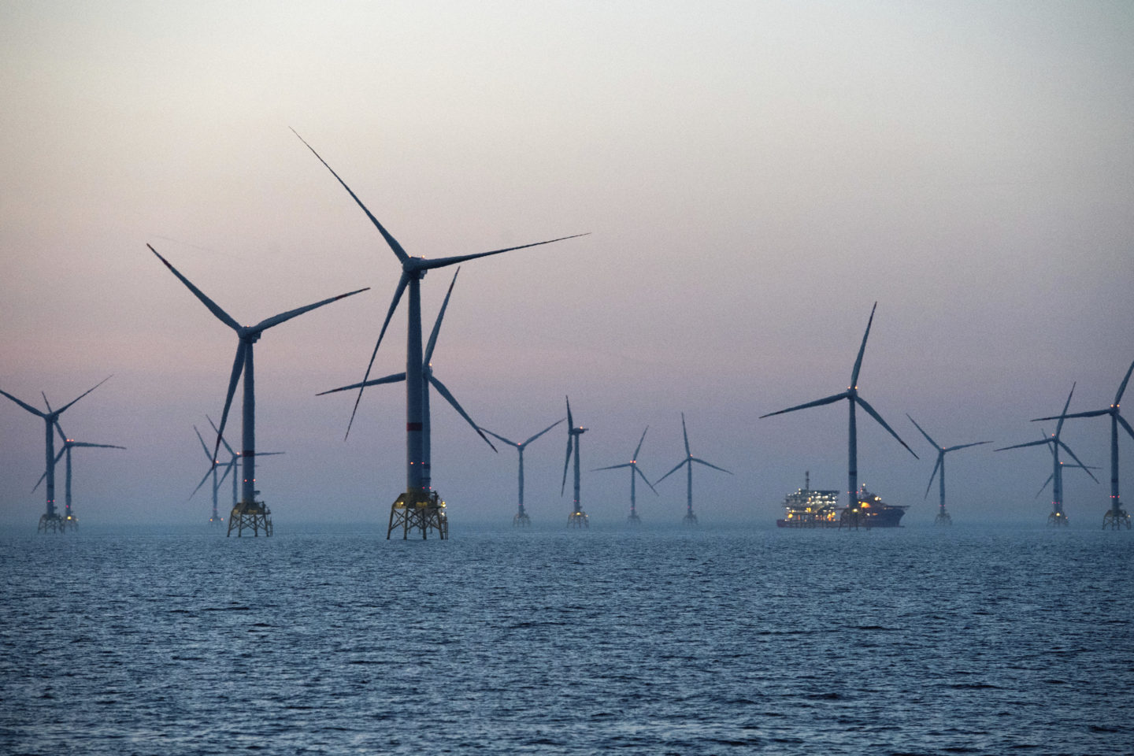

Offshore wind farm in Saudi Arabia

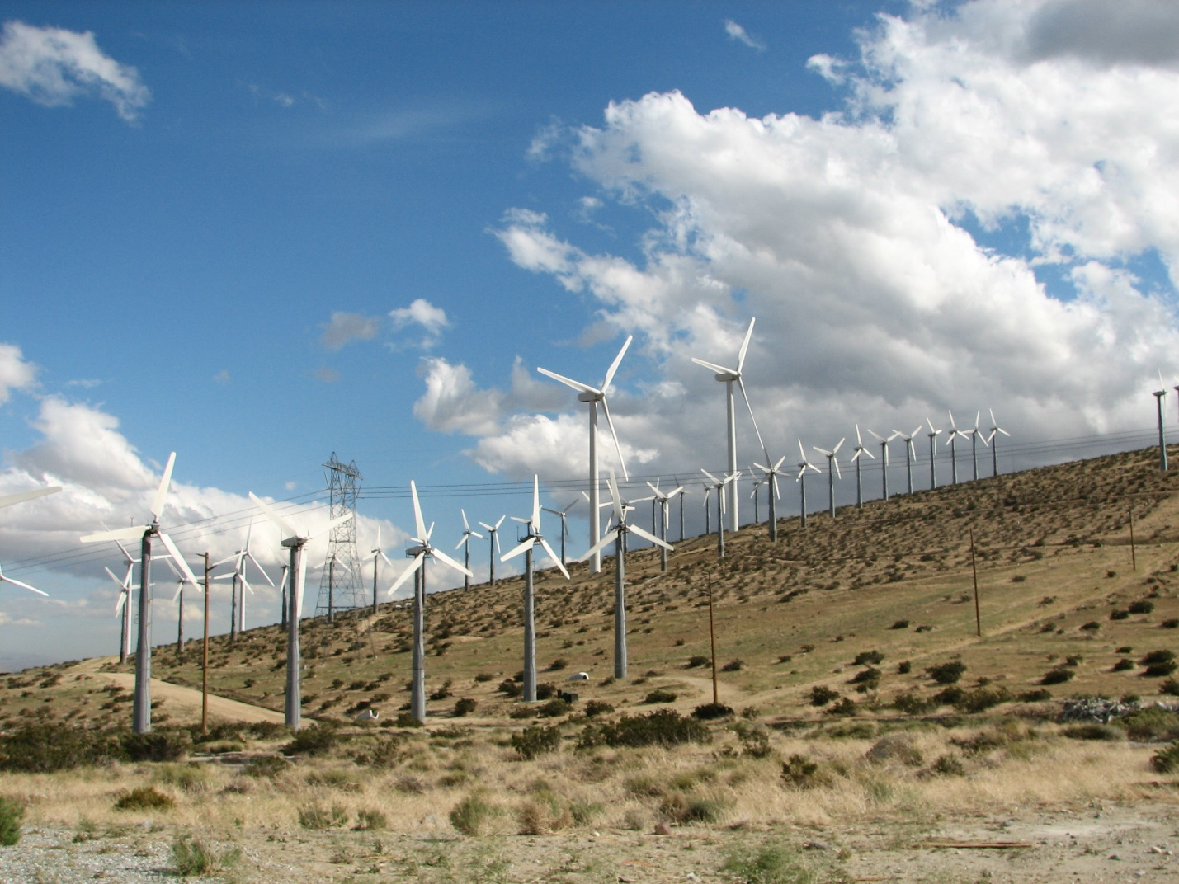

San Gorgonio Pass wind farm in California

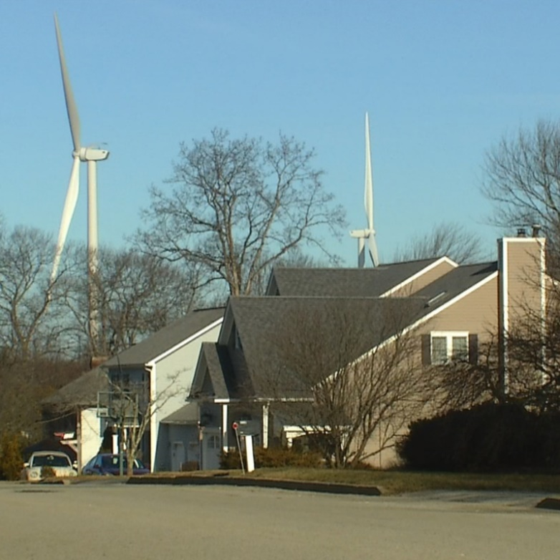

Neighborhood in Rhode Island

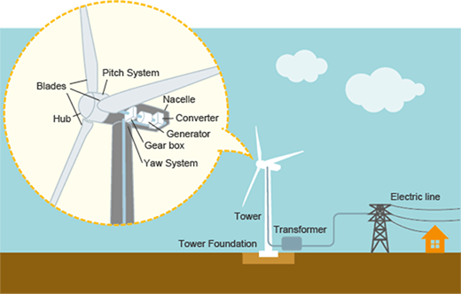

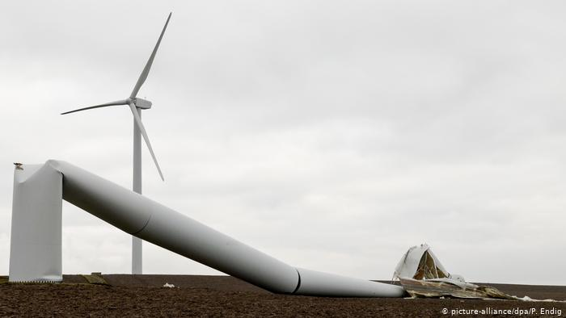

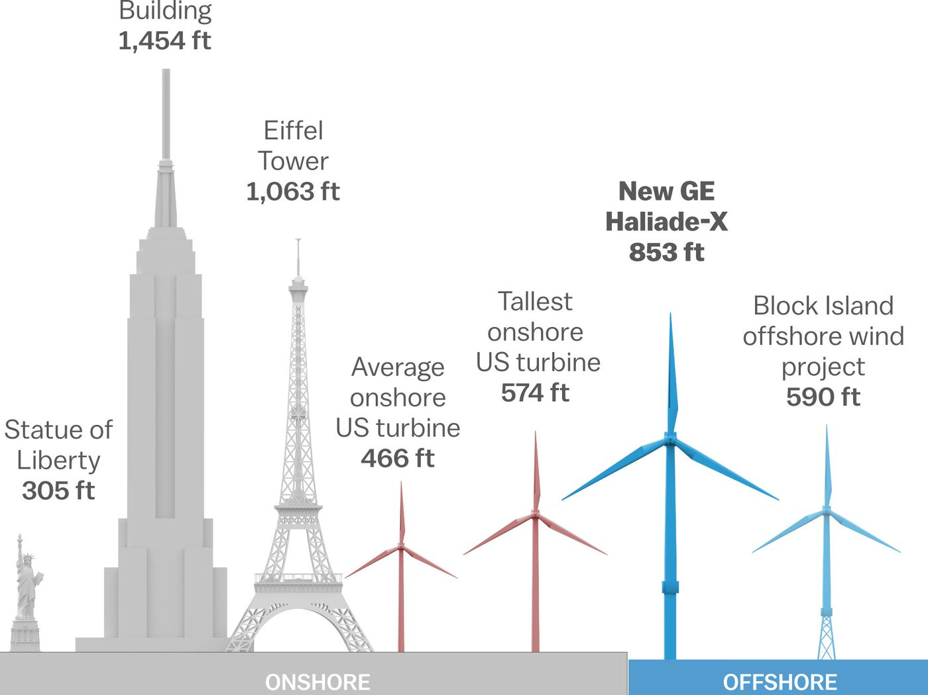

# Investigation – Hydro

1. Energy source name.
   1. Hydro
2. Is it renewable or non-renewable?
3. If non-renewable, how many years of world/U.S. reserves are left?
4. Is it used for electricity generation, heating, and/or transportation fuel?
5. What percent of California’s electricity or heating does the source supply? What percent of the U.S.’s transportation fuel does the source supply?
6. How is the source converted into usable energy?
7. Can the energy source produce energy upon demand (instantly)?
8. Is the energy from the source commonly used where it is generated?
9. Use resource maps or other data to comment on the abundance of the source in California and in your region of California.
10. How does the cost of using the energy source compare to alternatives?
11. What are the environmental costs and benefits of the energy source, including impacts on wildlife habitat, ecosystems, and the atmosphere?
12. Do you believe the source is overutilized, underutilized, or utilized at the right level in California? Why?

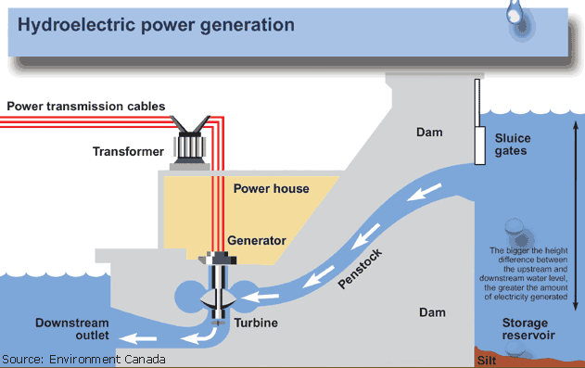

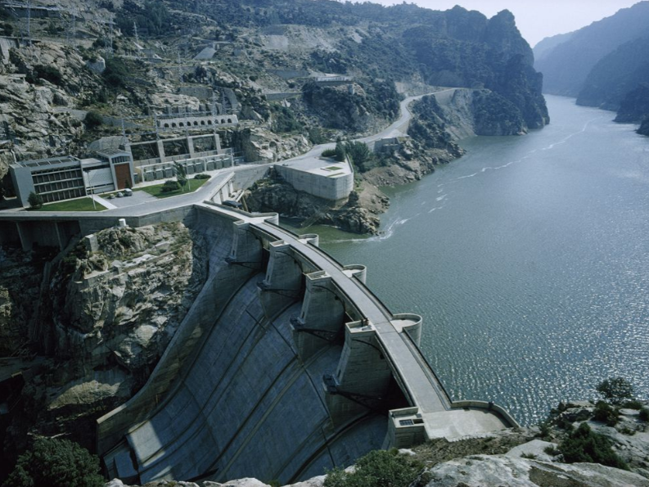

Hydroelectric dam in Portugal

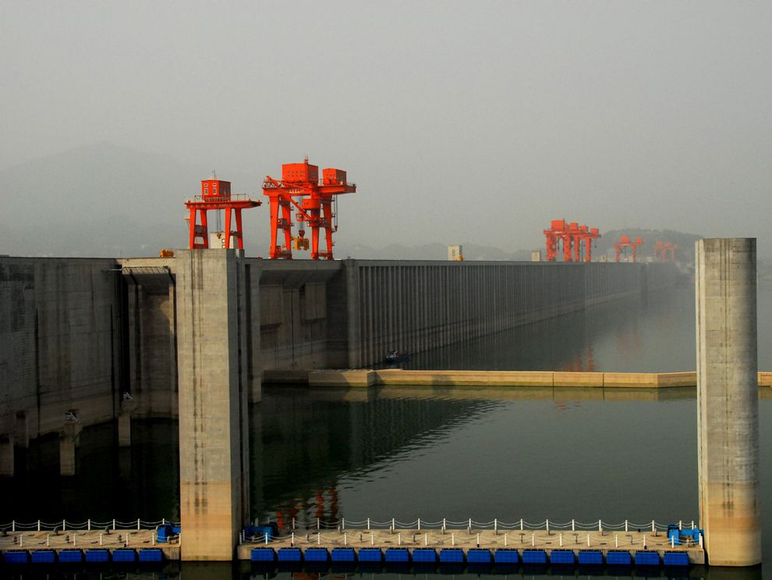

Three Gorges Dam in China (displaced 1.3 million people)

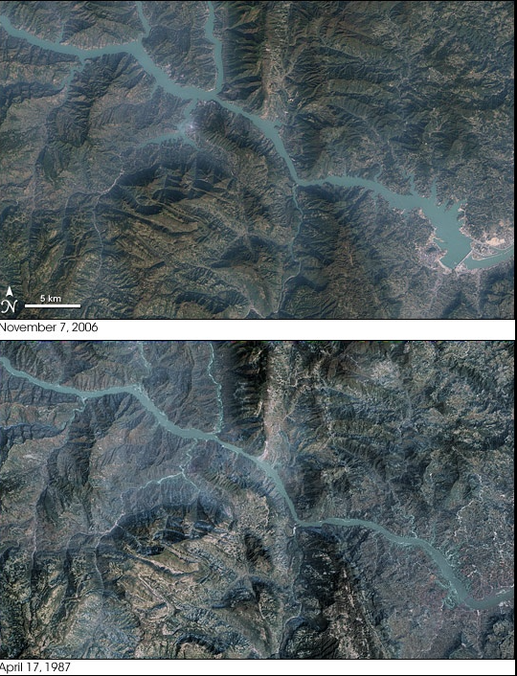

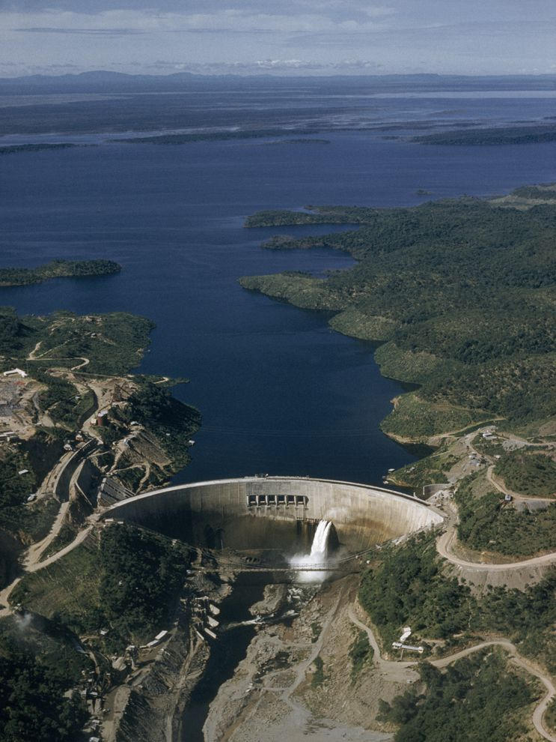

Kariba Dam in Zambia/Zimbabwe

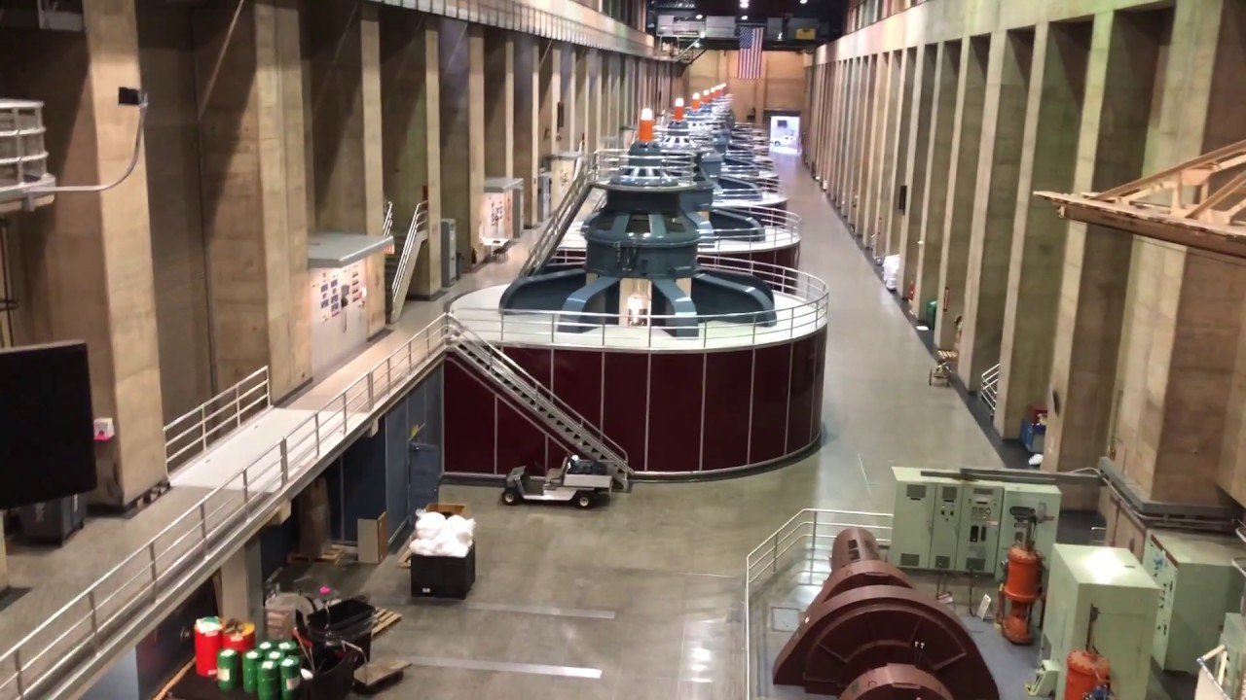

Turbines inside of Hoover Dam

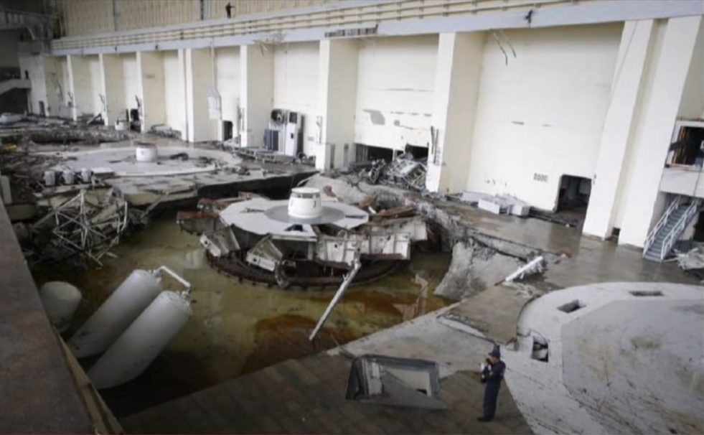

Hydroelectric dam failure in Russia

# Investigation – Geothermal

1. Energy source name.
   1. Geothermal
2. Is it renewable or non-renewable?
3. If non-renewable, how many years of world/U.S. reserves are left?
4. Is it used for electricity generation, heating, and/or transportation fuel?
5. What percent of California’s electricity or heating does the source supply? What percent of the U.S.’s transportation fuel does the source supply?
6. How is the source converted into usable energy?
7. Can the energy source produce energy upon demand (instantly)?
8. Is the energy from the source commonly used where it is generated?
9. Use resource maps or other data to comment on the abundance of the source in California and in your region of California.
10. How does the cost of using the energy source compare to alternatives?
11. What are the environmental costs and benefits of the energy source, including impacts on wildlife habitat, ecosystems, and the atmosphere?
12. Do you believe the source is overutilized, underutilized, or utilized at the right level in California? Why?

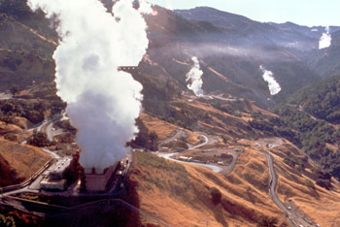

Geothermal energy plants in California

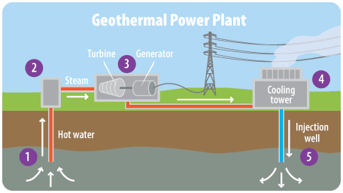

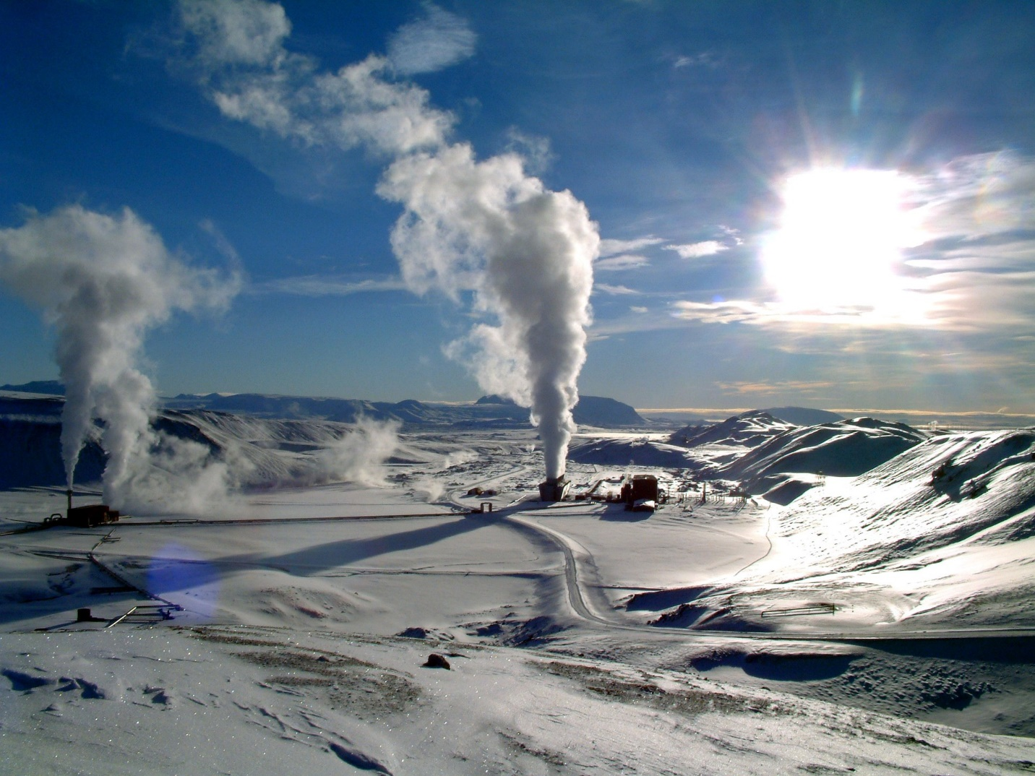

Geothermal plant in Iceland

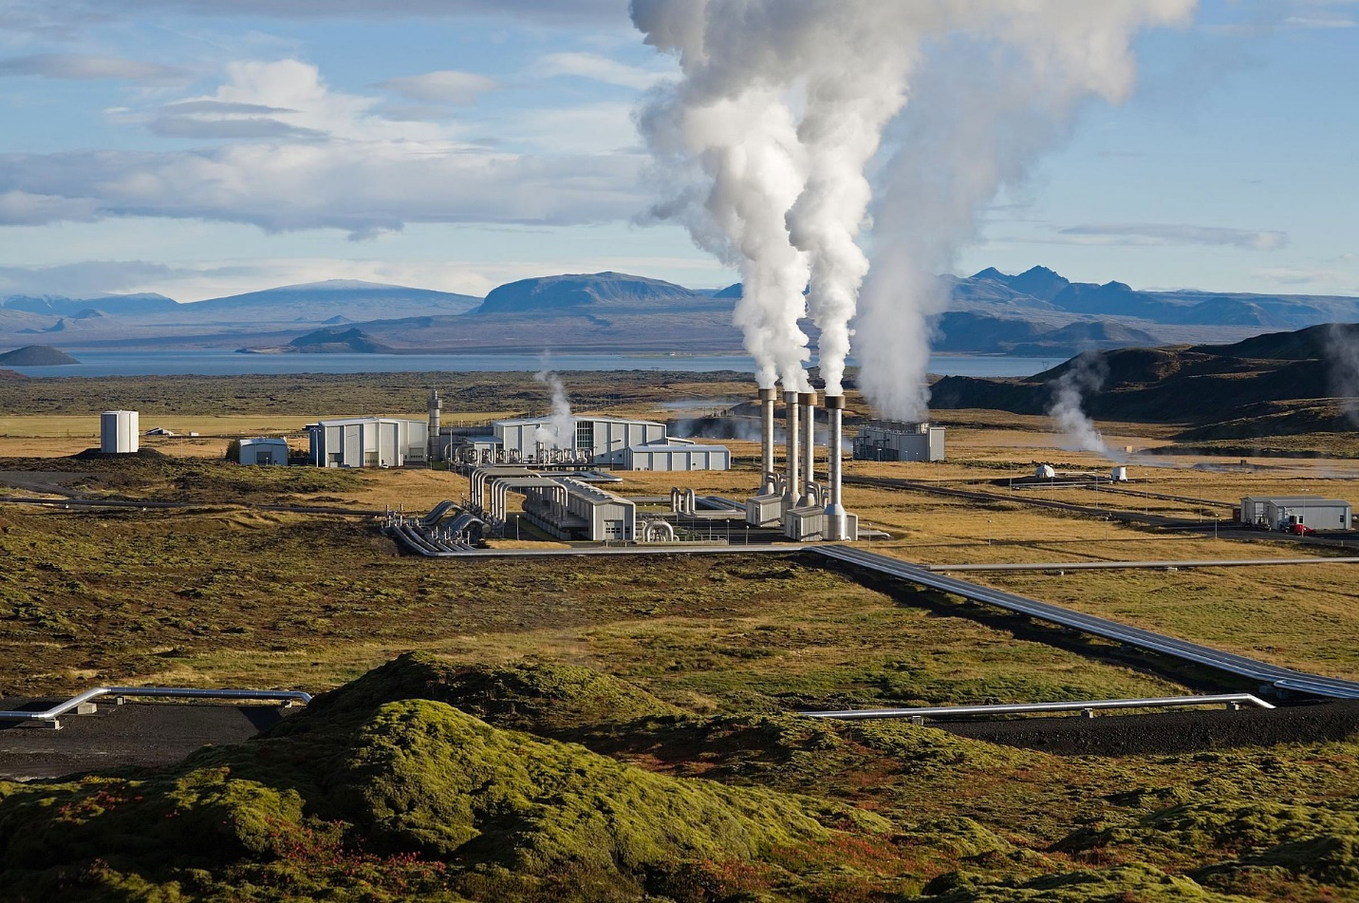

Geothermal Plant in Iceland

# Exit Survey

<https://forms.gle/rEuzFm4wWJhp7Jzp7>